**Smart Blind Stick for Obstacle Detection and Navigation**

Veeraragavan.N  
*School of Mechanical Engineering*  
*VIT Bhopal, University*Sehore, India  
veeranatarajan2305@gmail.com

Abhishek Shrivastava  
*School of Mechanical Engineering*   
*VIT Bhopal, University*Sehore, India  
abhishekujyan@gmail.com Vasudev. P  
*School of Mechanical Engineering*  
*VIT Bhopal, University*Sehore, India  
vasudev.23bmr10001@vitbhopal.ac.in

Rebecca Stanley Johnson  
*School of Mechanical Engineering*  
*VIT Bhopal, University*Sehore, India  
rebecca.23bmr10004@vitbhopal.ac.in

*Abstract*—Technological advancements are rapidly transforming lives, offering innovative solutions to enhance daily living. One such innovation is the smart stick, designed to assist sightless individuals in navigating their environment safely and independently. Sightless individuals often face significant challenges in performing daily activities, such as walking in the street or visiting friends and relatives, due to their inability to perceive their surroundings effectively. Traditional navigation aids, like white canes and guide dogs, have limitations, particularly in detecting obstacles beyond the immediate reach of the cane.

This paper presents the design and development of a smart stick, aimed at addressing these challenges by providing a reliable and efficient navigation aid. The system ensures comprehensive obstacle detection and alerts the user through real-time feedback, enabling them to navigate safely without fear of collisions. This innovative device significantly enhances the mobility and independence of sightless individuals, allowing them to interact more freely with their environment. By providing real-time feedback on obstacles, the smart stick addresses the limitations of traditional navigation aids and represents a significant step forward in assistive technology for the visually impaired.

Keywords: Smart Stick, Assistive Technology, Visually Impaired Navigation

# Introduction

Blind individuals face significant challenges in interacting with and perceiving their environment, as sight is the primary sense through which humans gather information. Approximately 83% of the information humans receive from their surroundings is through vision. The eyes, as organs of vision, play a crucial role in processing visual details and transmitting them to the brain, making them vital for daily activities and overall quality of life.

Historically, blind individuals have relied on guide dogs and white canes to navigate their surroundings. However, these traditional aids have limitations. The white cane, for instance, only provides information about objects it physically touches, which can be insufficient for detecting obstacles at a distance. To address these limitations, researchers have developed various smart devices designed to enhance the mobility and independence of blind individuals.

Blindness, defined as the inability to see, significantly impacts a person's ability to interact with their environment. With around 80% of environmental information obtained through sight, blind individuals often struggle to integrate into natural life. Traditional aids like the white cane, guide dogs, or assistance from other people have been essential but not entirely effective in providing comprehensive environmental awareness.

Recent advancements in technology have led to the development of smart sticks, which offer a more sophisticated solution for navigation. These devices incorporate various sensors and technologies to detect obstacles and provide real-time feedback to the user. For instance, K.S. Manikanta et al. utilized an Arduino NANO with an ultrasonic sensor and buzzer to detect obstacles [1]. Pratik N. K. et al. employed a Raspberry Pi microcontroller to control ultrasonic and IR sensors for obstacle detection [2]. Wall M.I. et al. proposed a smart stick using a PIC16F877A microcontroller and an ultrasonic sensor, which sends signals to an ISD1932 recorder/playback connected to a speaker [3].

Other researchers have explored different configurations and additional features to enhance the functionality of smart sticks. Mohd Helmy A. et al. used MPLAB software to program microcontrollers and ultrasonic sensors [4]. Ayat Nada et al. included a water sensor to detect water presence, while Ashraf Anwar et al. added IR and heat sensors to detect environmental conditions [5][6]. Vipual V. et al. combined ultrasonic and moisture sensors with a PIC16F87A microcontroller, triggering a buzzer to alert the user of obstacles [7].

Innovative designs, such as those by Roland N. et al., incorporate radio frequency technology to help locate the stick if misplaced. These designs often use traditional walking canes as the main frame, with sensors mounted at strategic locations to detect obstacles and water. The sensors send signals to an Arduino chip, which communicates with an alarm unit comprising a buzzer and vibrator to notify the user [8].

Vinay S. et al. utilized the Goal Oriented Requirements Engineering (GORE) methodology to design a smart stick based on Radio Frequency Identification (RFID) technology, enhancing the user's shopping experience [9].

Manikandan Sh. et al. added GPRS and GSM modules to their design, allowing family members to track the user if they get lost [10]. Dada E. Gb et al. developed a simple circuit for a smart stick with an ultrasonic sensor and water sensor connected to an Arduino [11].

This paper aims to present a comprehensive overview of the design and development of a smart stick, highlighting its potential to significantly improve the mobility and independence of blind individuals. By leveraging advanced technologies and innovative designs, the smart stick represents a significant step forward in assistive technology for the visually impaired..

# Review Work

The development of obstacle-avoiding sticks for visually impaired individuals has seen significant advancements in recent years. Raghu N. et al. (2024) focused on an IoT-enabled smart stick equipped with ultrasonic sensors, voice feedback, and emergency alert features, providing comprehensive assistance for navigation. Farooq MS. et al. (2022) described the design and development of an intelligent stick using IoT for detecting obstacles and providing real-time alerts via GPS, enhancing the user's ability to navigate unfamiliar environments safely. Akhil P. et al. (2022) discussed the use of infrared and ultrasonic sensors in a walking stick, aiding visually impaired users in detecting stairs and other obstacles, thus improving safety and mobility. Apprey MW. et al. (2022) developed a solar-powered navigation stick designed to assist the blind, using sensors to ensure obstacle avoidance and leveraging solar energy for sustainability. Gharghan SK. et al. (2024) presented a smart stick navigation system based on IoT, which uses various sensors to detect obstacles and provide real-time feedback, making it a versatile tool for visually impaired individuals. Despite these advancements, several research gaps remain, including the accuracy and range of sensors, battery life, environmental factors affecting obstacle detection, and the need for improved user interaction through additional sensory inputs such as voice commands, GPS, or haptic feedback.

# Proposed Work

The proposed work aims to develop an obstacle-avoiding stick for visually impaired individuals with several key objectives and methodologies. The primary objective is to assist those with vision impairments in identifying obstacles using sensors such as infrared or ultrasonic. The system will provide immediate feedback through buzzers, audio alarms, or vibrations, ensuring quick response to detected obstacles. In case of mishaps, the stick can notify authorities or caretakers of an emergency. Additionally, it can sense hard falls and send an emergency SMS with location information to preregistered contacts. The system will use readily available technology, such as vibration motors, GSM modules, MPU 6050 module, and ultrasonic sensors, to create a cost-effective solution.

Implementation involves preprocessing sensor signals to reduce noise, integrating ultrasonic sensors for obstacle detection and the MPU 6050 module for fall detection, providing feedback through buzzers and vibration motors, and using a GSM module for emergency notifications.

The system architecture will be centered around a microcontroller, powered by a rechargeable battery with potential solar panel integration. Future enhancements may include machine learning models to anticipate barrier shifts, improved emergency alert systems, AI for better obstacle recognition, energy-efficient components, and advanced sensors like LiDAR for more accurate detection. This approach aims to provide safer, more independent, and easier navigation for visually impaired individuals.

1. table of features, advantages, and limitations of the project:

|  |  |  |  |
| --- | --- | --- | --- |
| ****Feature**** | ****Description**** | ****Advantages**** | ****Limitations**** |
| ****Ultrasonic****  ****Sensors**** | Sensors used to  detect obstacles by  emitting ultrasonic  waves and measuring the reflection time. | Accurate obstacle  detection, works in  various lighting  conditions. | Limited range, may  not detect very small or thin obstacles. |
| ****MPU 6050 Module**** | Module combining a 3-axis gyroscope and a 3-axis accelerometer for fall detection. | Accurate  fall detection,  provides real-time  data. | May require  calibration, sensitive  to sudden  movements. |
| ****Buzzers****  ****and****  ****Vibration****  ****Motors**** | Components  providing immediate feedback to the user through sound and  vibrations. | Immediate and clear feedback, easy to  understand. | May cause discomfort with prolonged use,  limited feedback  types. |
| ****GSM****  ****Module**** | Module used to send emergency SMS  notifications with  location information. | Provides real-time  emergency alerts,  ensures prompt  assistance. | Requires cellular  network coverage,  may incur additional  costs. |
| ****Rechargeable Battery**** | Power supply for the system, rechargeable for continuous use. | Sustainable power  supply, reduces  need for frequent  Battery  replacements. | Limited battery life,  requires regular  recharging. |
| ****Microcontroller**** | Core component  processing data fromsensors and  controlling feedback mechanisms. | Efficient data  processing,  customizable  programming. | Requires  programming  knowledge, may  have  limited processing  power. |

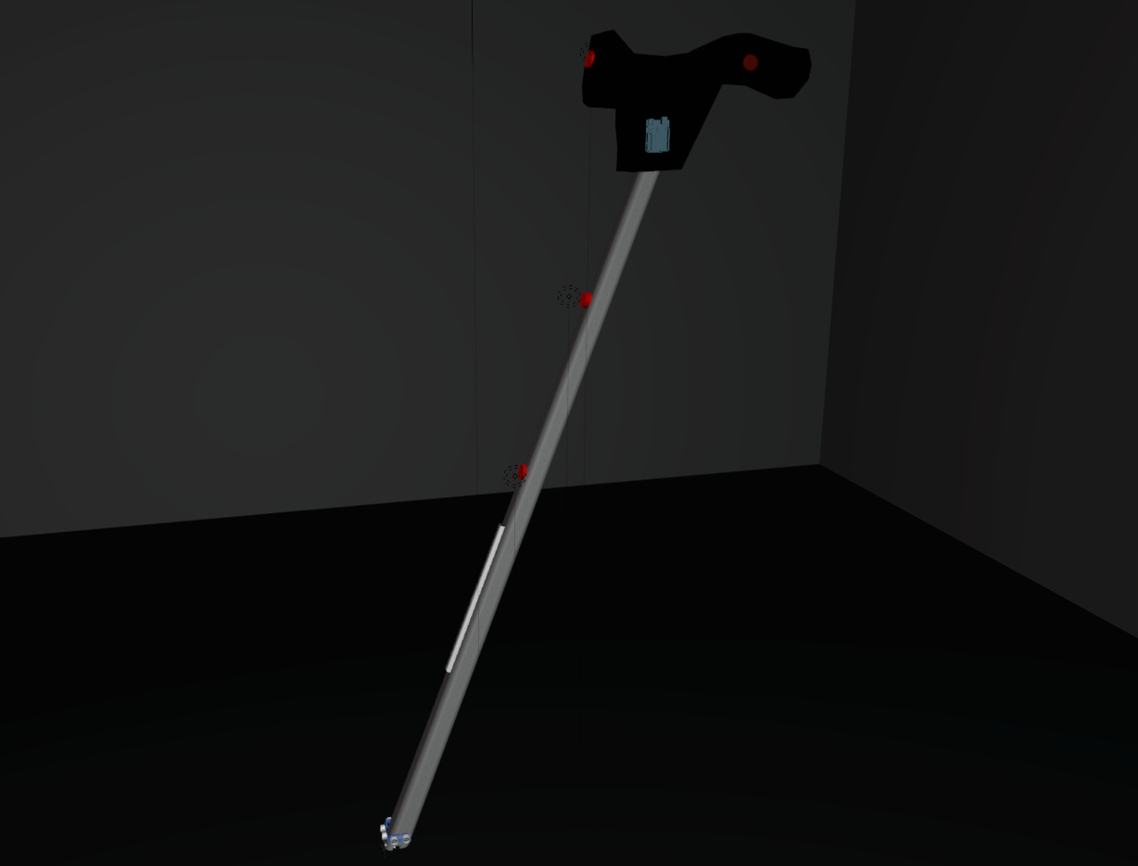

1. Model of the project.

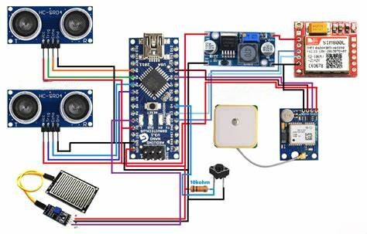

1. Circuit diagram of smart blind stick

# Calculations

## Distance Calculation Using Ultrasonic Sensors:

Formula:

C:/Users/veera/AppData/Local/Temp/wps.mEErGJwps

Explanation:

* The ultrasonic sensor sends a sound wave that reflects off an obstacle and returns.
* The time measured includes the wave traveling to the obstacle and back. Hence, we divide by 2 to calculate the one-way distance.
* The speed of sound is assumed to be 343 m/s (in air, at 20°C).

Example Calculation:

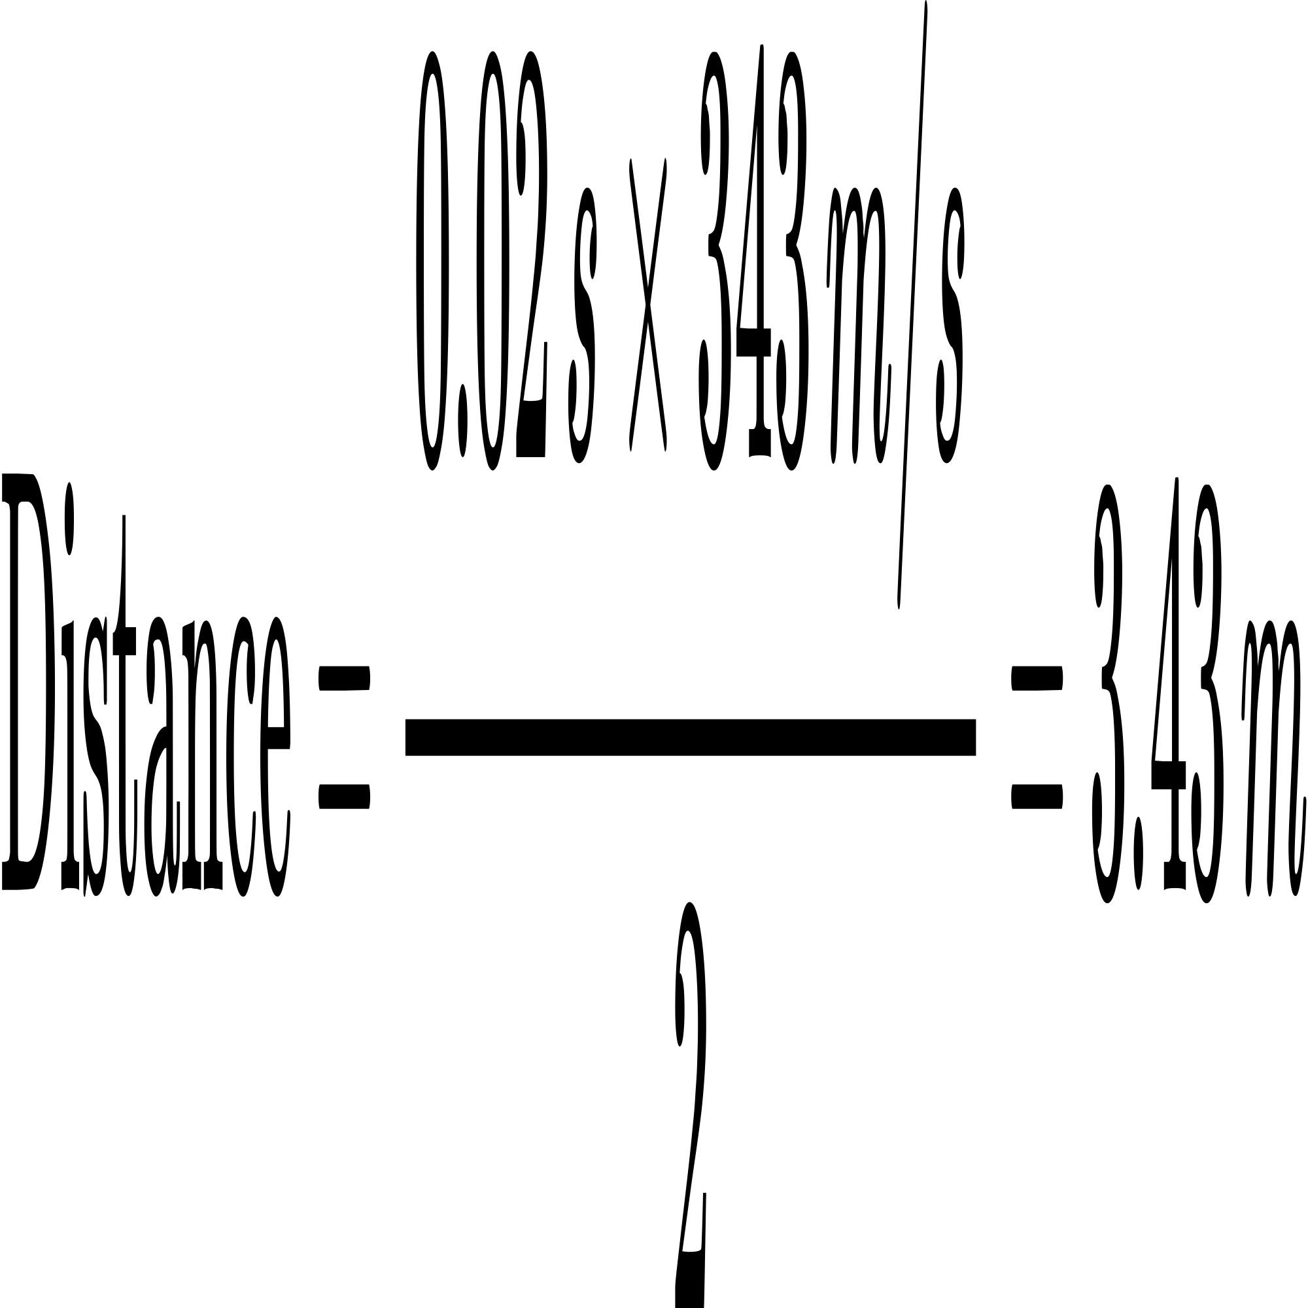

Here, 0.02 seconds is the round-trip time, and the calculated distance is 3.43 meters.

## Fall Detection Using Accelerometer

Formula:

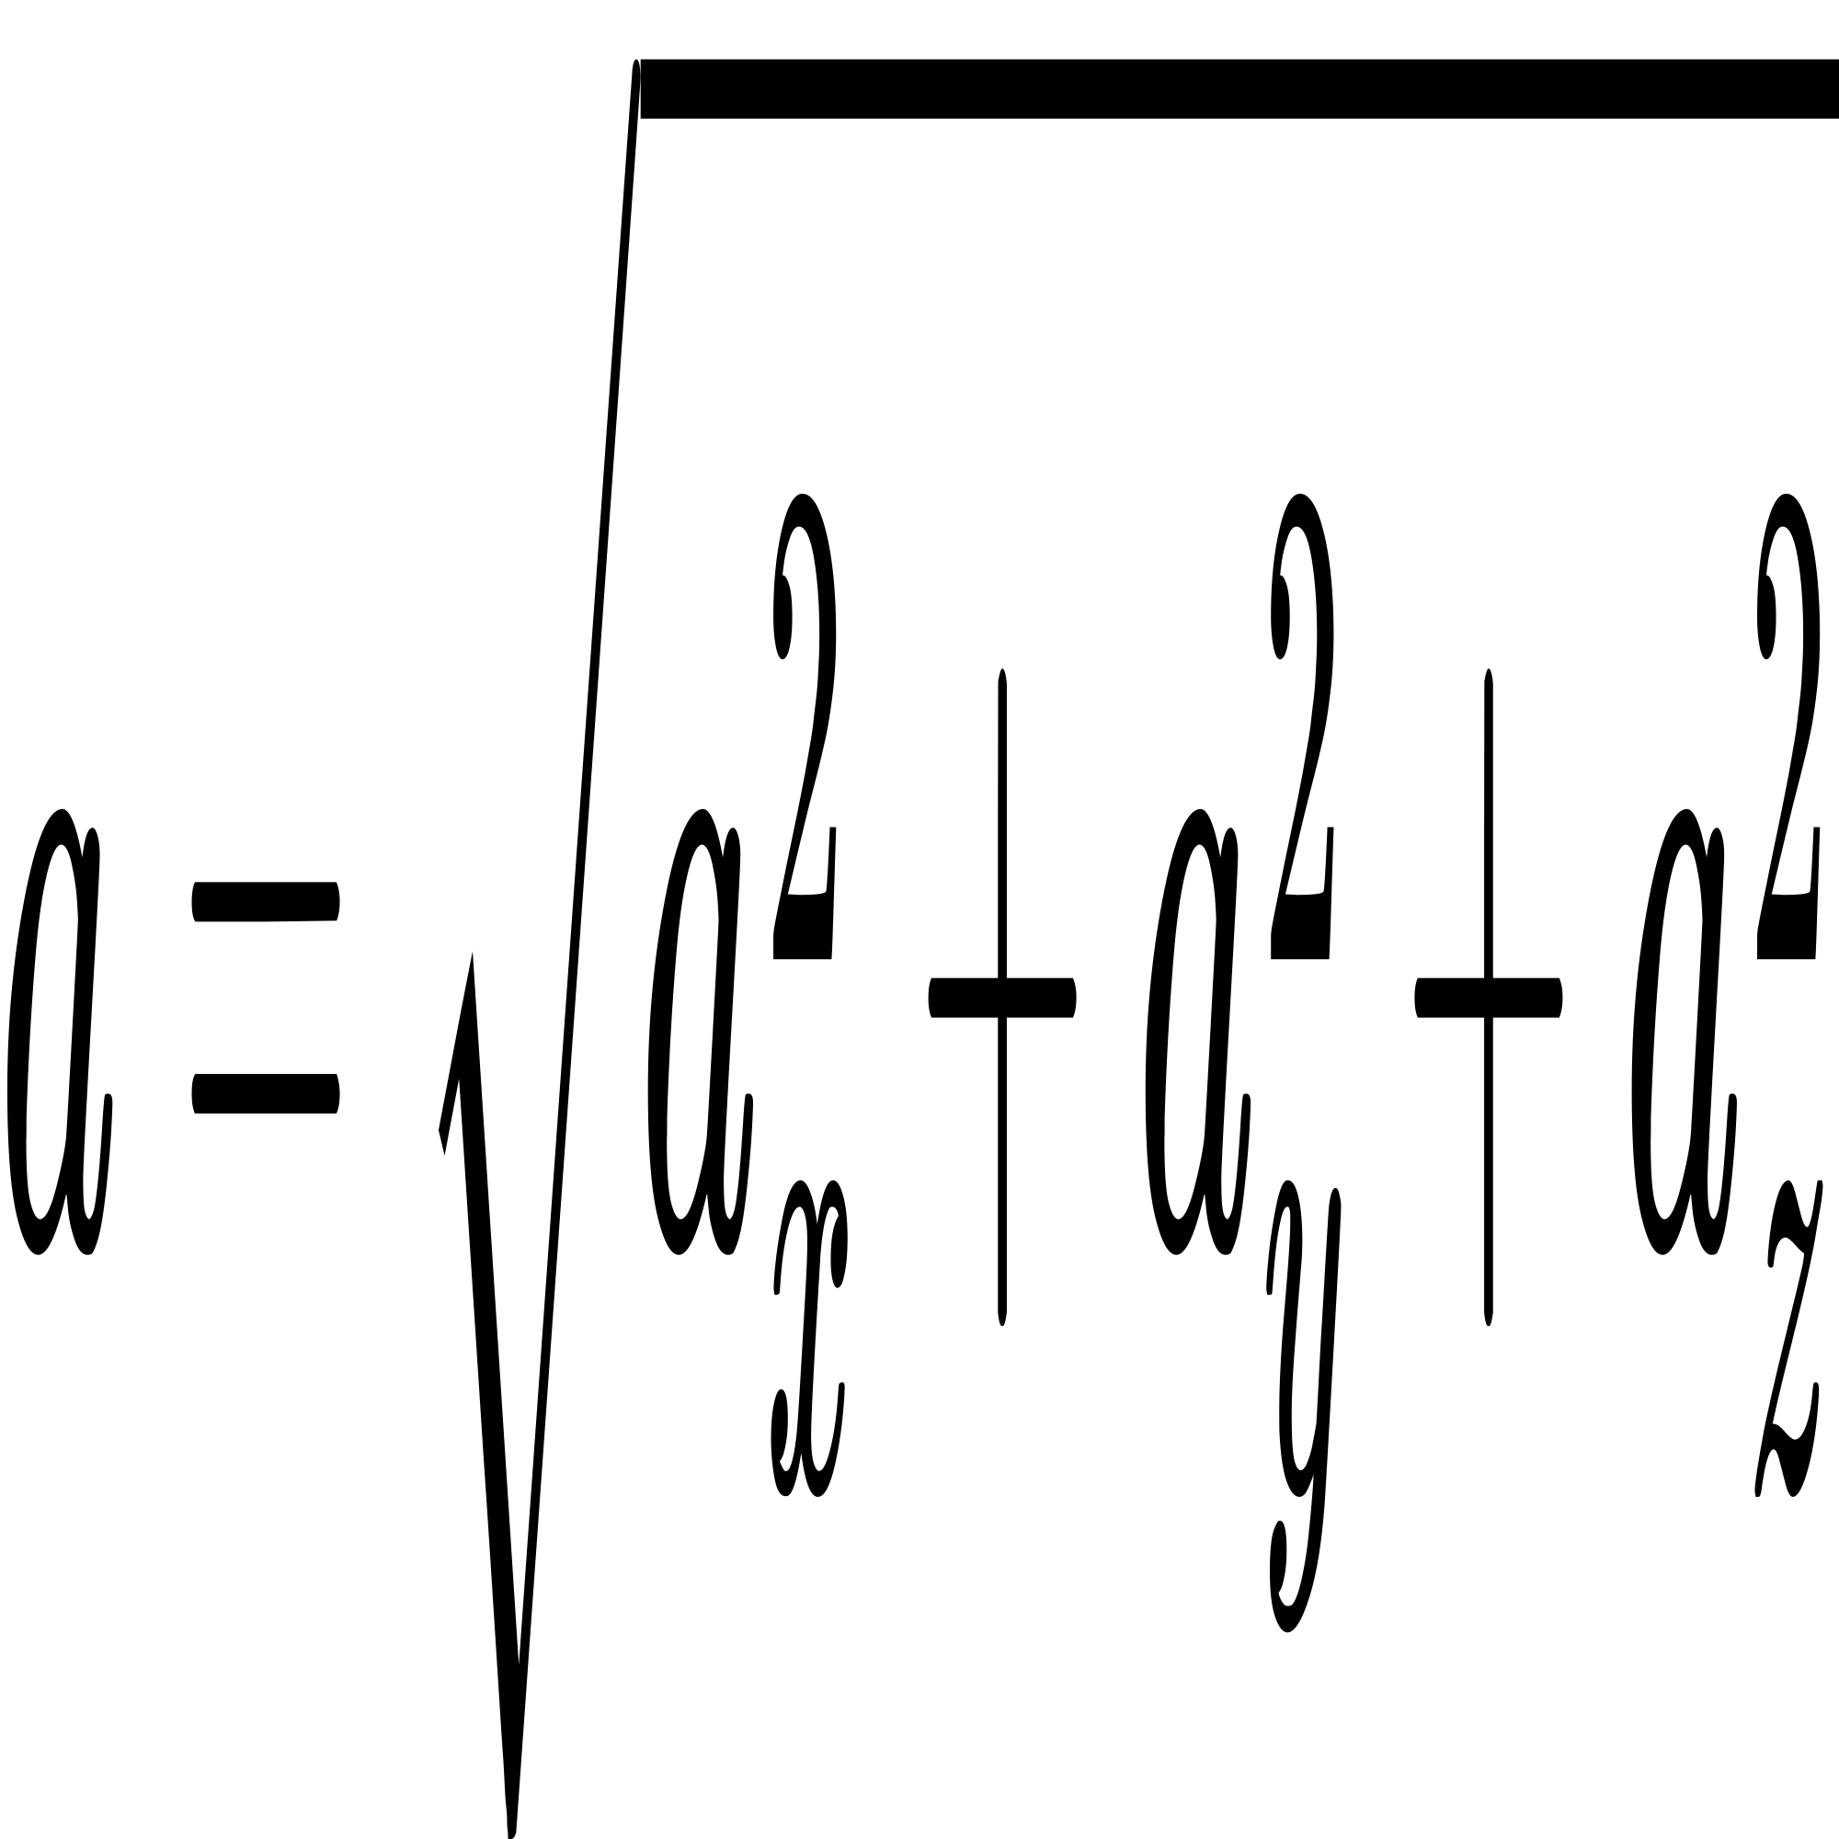

Explanation:

* An accelerometer measures acceleration in three dimensions: x, y, and z.
* The resultant acceleration ‘a’ combines these values to detect motion changes, like a fall.

Example Calculation:

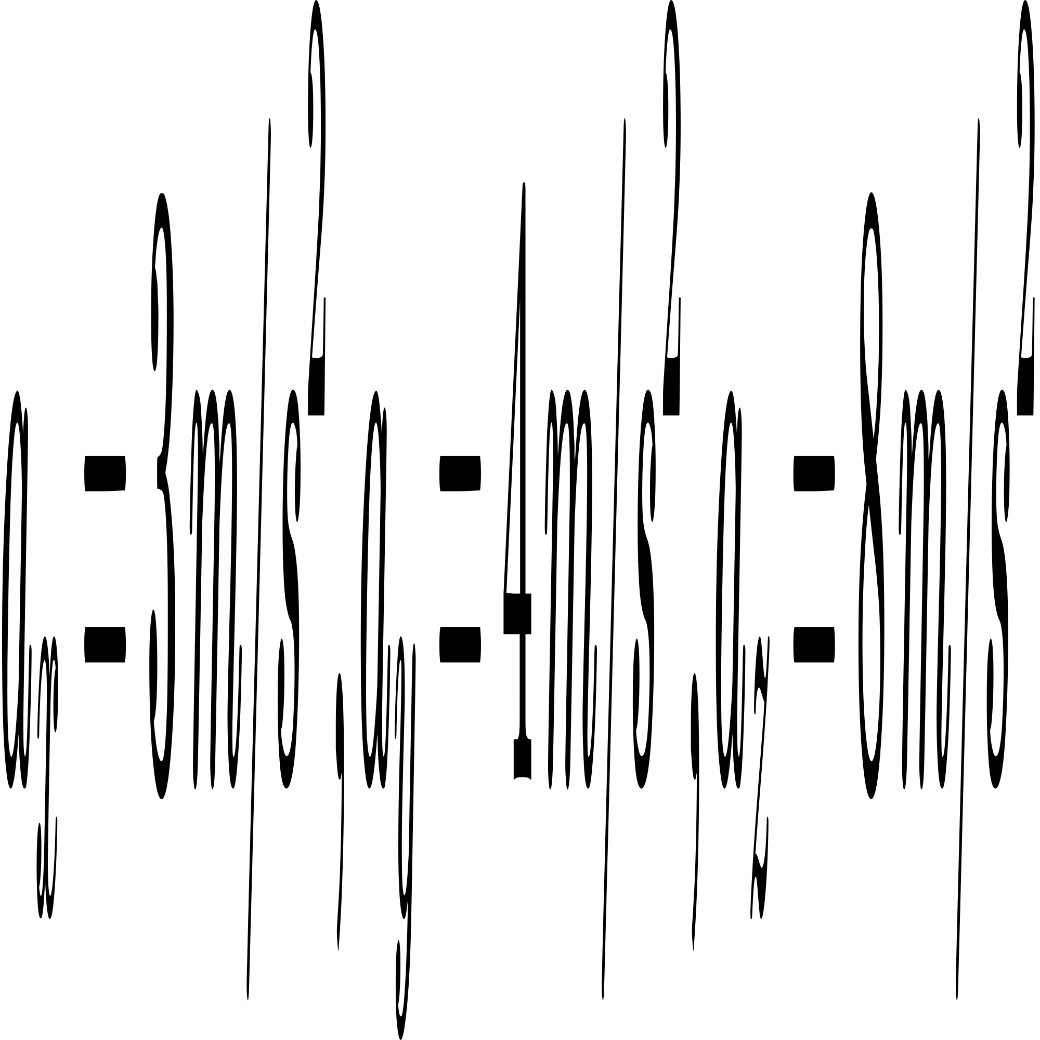

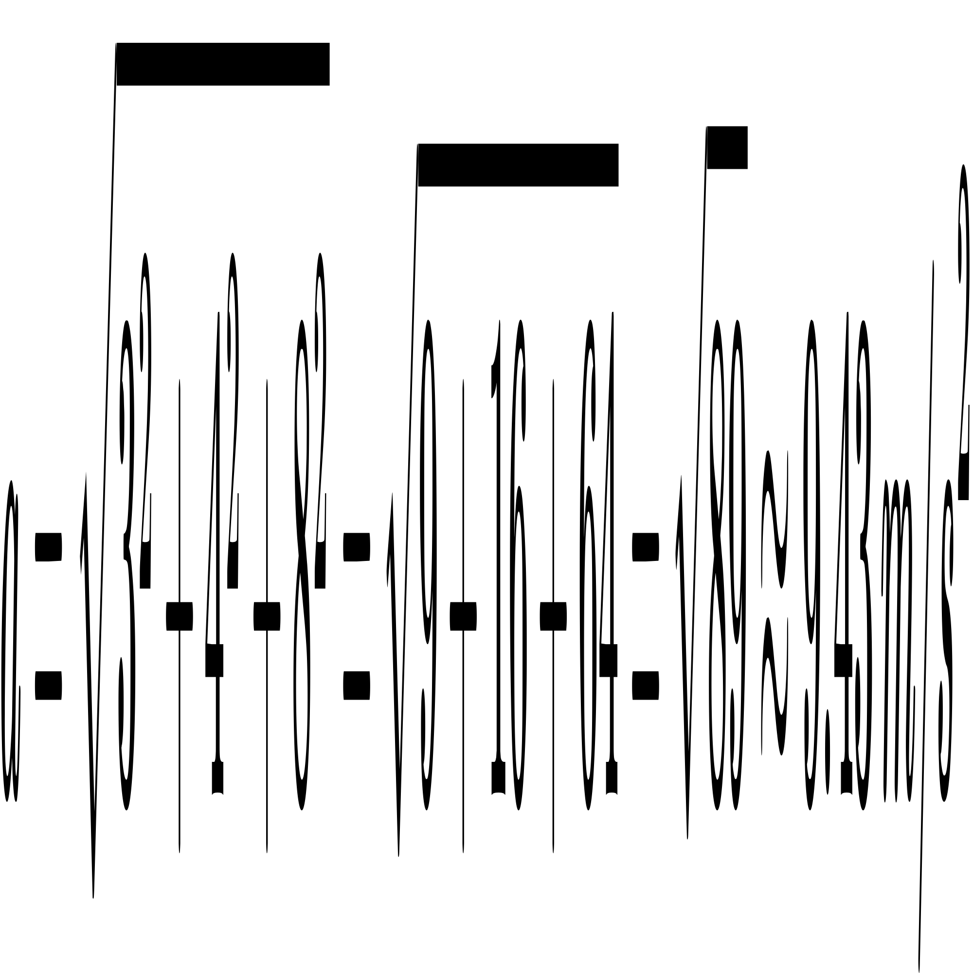

This value indicates a potential impact event.

## Power Consumption Calculation

Formula:



Explanation:

* Electrical power (P) is the product of voltage (V) and current (I).
* P is measured in Watts (W), V in Volts (V), and I in Amperes (A).

Example Calculation:

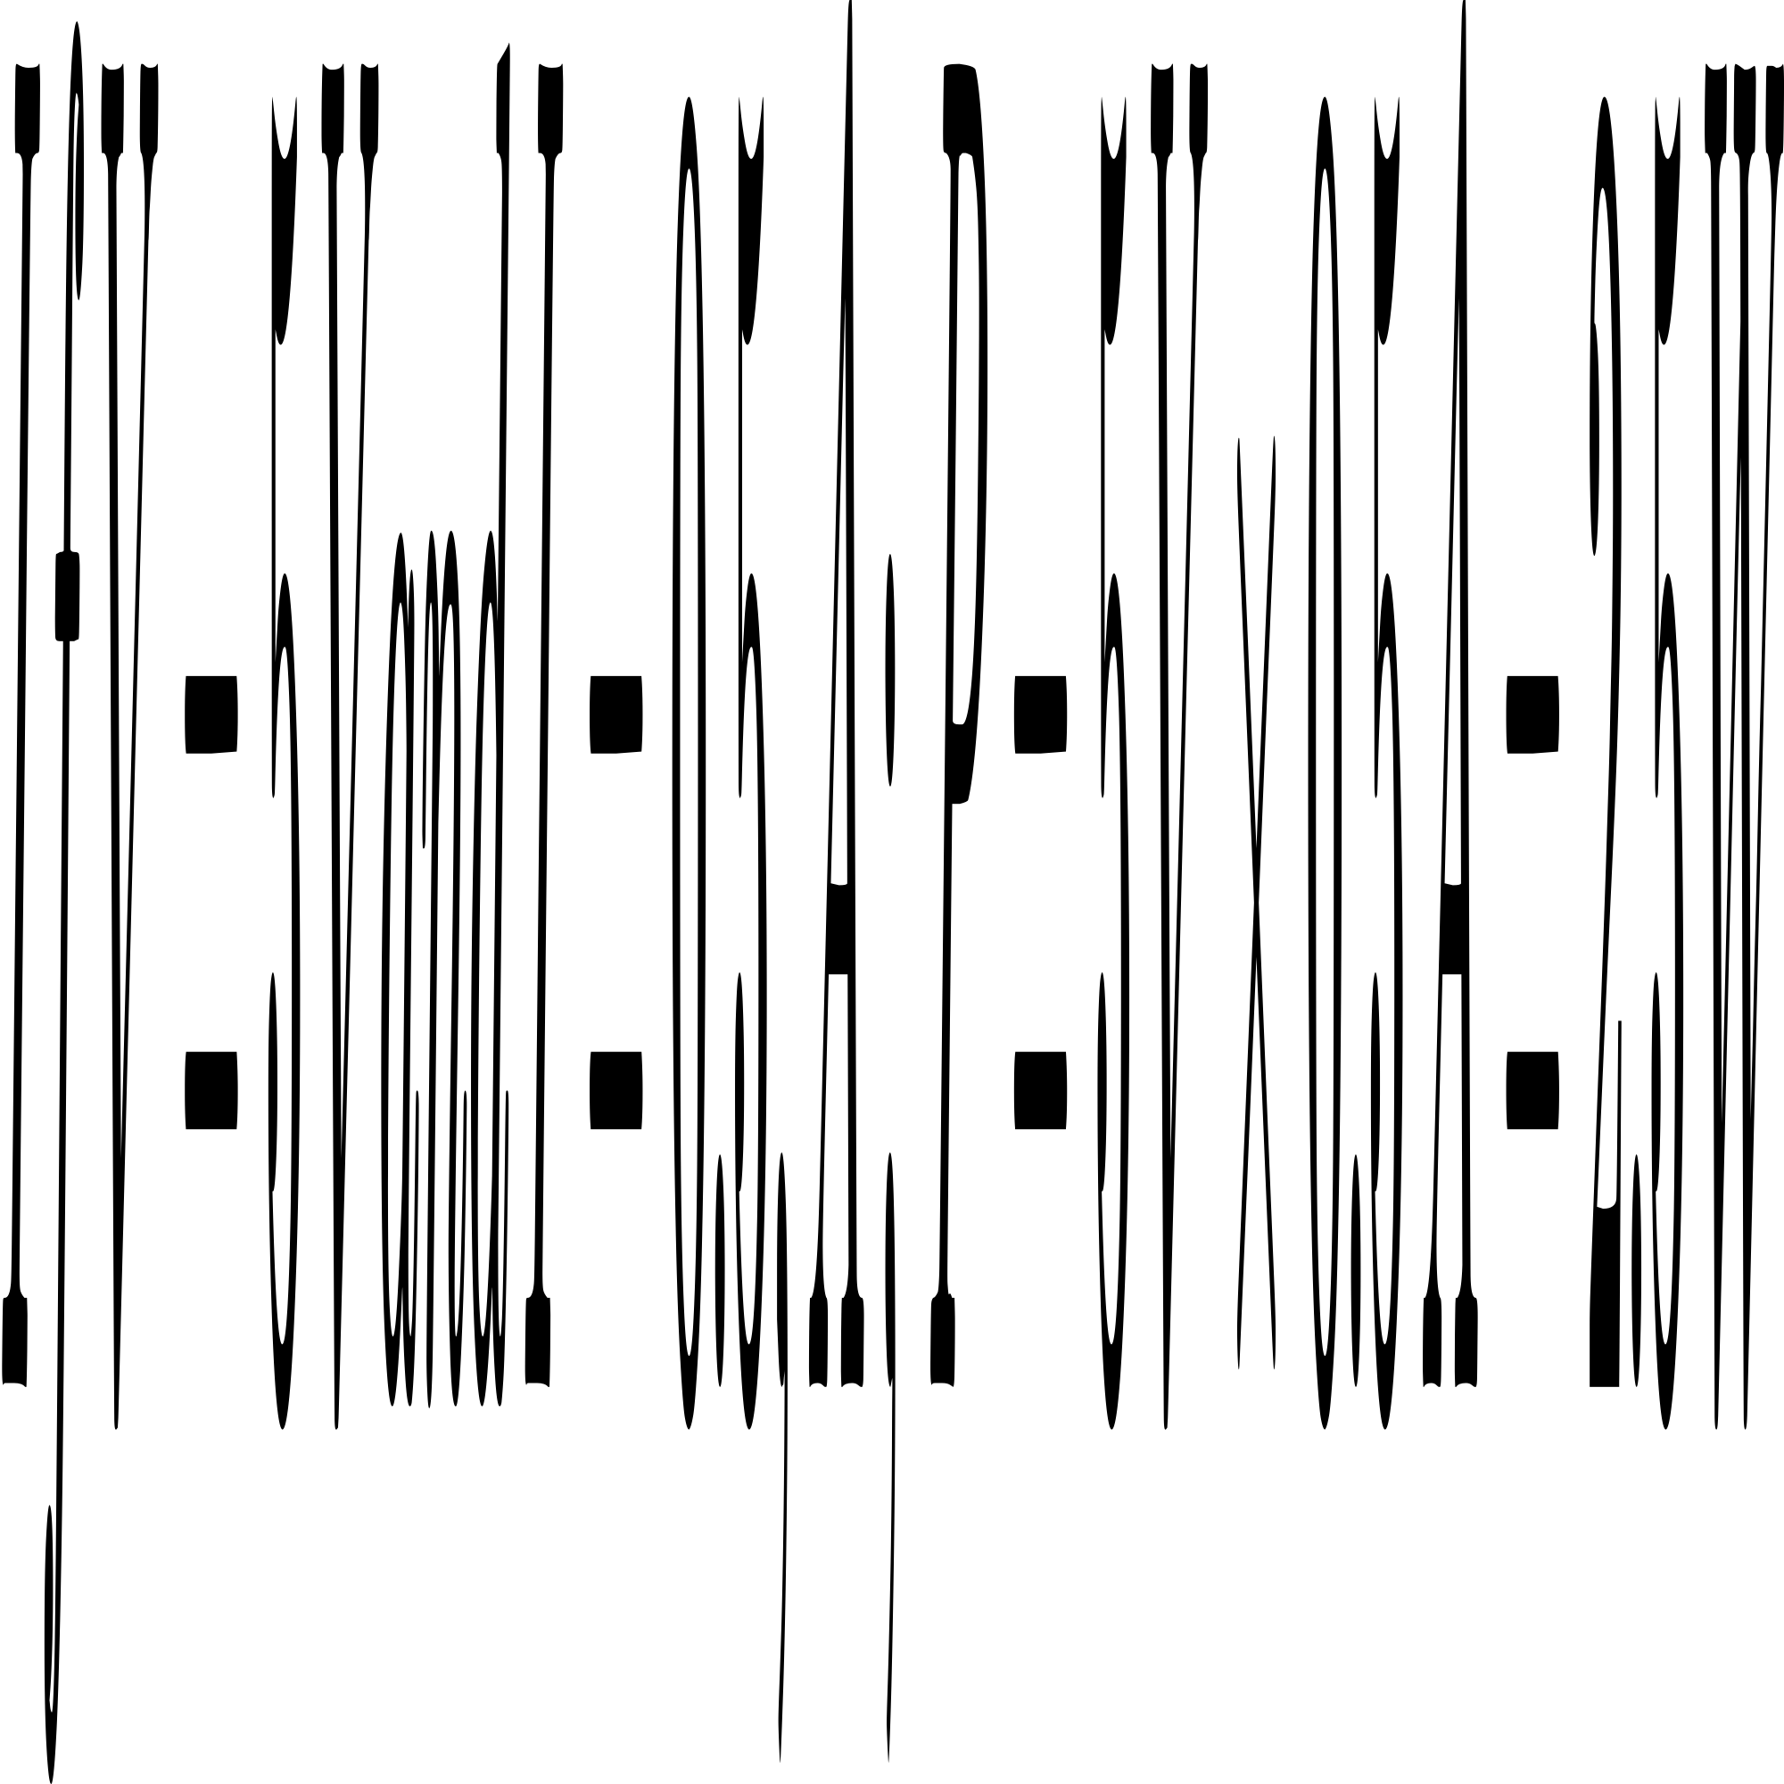

This means the device consumes 2.5 Watts of power.

1. Calculations and results of the components

| **Calculations** | **Example values** | **Result** |
| --- | --- | --- |
| **Distance Calculation** | Time = 0.02 s, Speed of Sound = 343 m/s | 3.43 m |
| **Fall Detection** | wps | 9.43 m/s² |
| **Power Consumption** | Voltage = 5V, Current = 0.5A | 2.5 W |
| **Battery Life Estimation** | Battery Capacity = 2000 mAh, Current Consumption = 500 mA | 4 hours |
| **GPS Distance Calculation** | Coordinates: (52.2296756, 21.0122287) and (41.8919300, 12.5113300) | 1210 km |

The calculations for the obstacle-avoiding stick project involve several key aspects. First, the distance to obstacles is determined using ultrasonic sensors, where the time taken for sound waves to travel to and from the obstacle is measured and multiplied by the speed of sound, then divided by two. For fall detection, the resultant acceleration is calculated using the accelerometer readings along the x, y, and z axes, providing a measure of sudden movements. Power consumption is calculated by multiplying the voltage and current, while battery life is estimated by dividing the battery capacity by the current consumption. Finally, the Haversine formula is used to calculate the distance between two GPS coordinates, providing an accurate measure of the distance traveled. These calculations ensure the device's functionality and reliability in real-world scenarios.

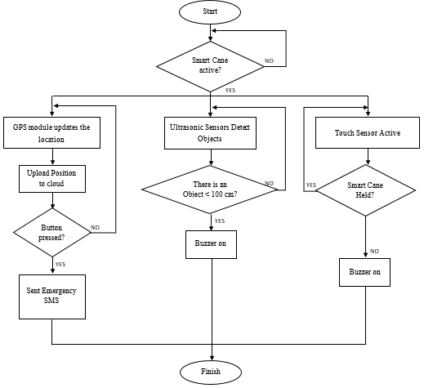

1. Flow chart for determining the working of smart blind stick

# Technical Specifications

## Ultrasonic Sensors:

These sensors are mounted on the stick to detect obstacles. They emit ultrasonic waves and measure the time it takes for the waves to bounce back from an obstacle.

## MPU 6050 Module:

This module includes a 3-axis gyroscope and a 3-axis accelerometer to detect falls. It measures the acceleration along the x, y, and z axes.

## Microcontroller:

The microcontroller acts as the brain of the system. It processes data from the ultrasonic sensors and the MPU 6050 module. Based on the sensor inputs, it activates the appropriate feedback mechanisms.

## Feedback Mechanisms:

### Buzzers:

Emit sound alerts when an obstacle is detected.

### Vibration Motors:

Provide haptic feedback to the user, indicating the presence of an obstacle or a fall

## GSM Module:

In case of a fall or emergency, the microcontroller uses the GSM module to send an SMS notification with the user's location to pre-registered contacts. This ensures that help can be dispatched promptly.

## Power Supply:

The system is powered by a rechargeable battery, which can be supplemented with solar panels for sustainable energy.

1. theoretical results of the smart blind stick

| **Aspect** | **Description** | **Expected Result** |
| --- | --- | --- |
| **Obstacle Detection** | Detection range of ultrasonic sensors | 3.43 meters |
| **Fall Detection** | Detection of falls using MPU 6050 module | Significant deviations from 9.8 m/s² trigger alerts |
| **Feedback Mechanisms** | Immediate feedback through buzzers and vibration motors | Clear and understandable feedback for safe navigation |
| **Emergency Notification** | Sending SMS notifications with location information via GSM module | Prompt notifications ensuring timely assistance |
| **Power Consumption** | Power consumption of the system | 2.5 watts |
| **Battery Life** | Estimated battery life based on battery capacity and current consumption | 4 hours |
| **Solar Panel Integration** | Additional power supply through solar panels | Extended battery life during daylight hours |
| **Environmental Factors** | Potential impact of environmental conditions on system performance | Performance may be affected by extreme weather or electronic interference |

# Discussion

The theoretical results indicate that the obstacle-avoiding stick has the potential to significantly enhance the mobility and safety of visually impaired individuals. Accurate obstacle detection and immediate feedback mechanisms are expected to ensure confident navigation. The fall detection feature adds an extra layer of safety by alerting caregivers or emergency contacts in case of an accident.Power consumption and battery life calculations suggest that the system is energy-efficient and can operate for extended periods without frequent recharging. Solar panels further enhance the device's sustainability, making it suitable for long-term use.However, the range of the ultrasonic sensors is limited to 3.43 meters, which may not be sufficient in all scenarios. Environmental factors such as extreme weather conditions or electronic interference could also affect performance.Future work could focus on integrating advanced sensors with longer ranges and higher accuracy, incorporating machine learning algorithms for improved obstacle detection, and enhancing the emergency notification system with real-time tracking and health monitoring features.Overall, the theoretical analysis and calculations demonstrate that the obstacle-avoiding stick project has significant potential to improve the quality of life for visually impaired individuals, providing a valuable tool for independent navigation and safety.

# Conclusion

The development of the smart blind stick represents a significant advancement in assistive technology for visually impaired individuals. By integrating ultrasonic sensors, the MPU 6050 module, and GSM modules, the device provides comprehensive obstacle detection and immediate feedback through buzzers and vibration motors. This ensures that users can navigate their environment safely and independentlyThe theoretical results and calculations demonstrate the device's potential to significantly improve the mobility and safety of visually impaired individuals. The system's energy efficiency, supported by rechargeable batteries and optional solar panels, ensures long-term usability without frequent recharging. However, the range of the ultrasonic sensors and the impact of environmental factors on performance are areas that require further improvementIn conclusion, the smart blind stick is a valuable contribution to assistive technology, offering a practical, economical, and effective solution for enhancing the independence and safety of visually impaired individuals. Continued research and development in this area will undoubtedly lead to even more sophisticated and user-friendly devices, further improving the quality of life for those with vision impairments.

***Acronym words:***

##### **IoT:** Internet of Things

##### **RFID:** Radio Frequency Identification

##### **GPS:** Global Positioning System

##### **LiDAR:** Light Detection and Ranging

##### **AI:** Artificial Intelligence

##### **ML:** Machine Learning

##### **HCI:** Human-Computer Interaction

##### **LED:** Light Emitting Diode

##### **PWM:** Pulse Width Modulation

##### **BLE:** Bluetooth Low Energy

##### References

1. K.S. Manikanta et al. (2020) - Utilized an Arduino NANO with an ultrasonic sensor and a buzzer to detect obstacles, providing a basic yet effective solution for obstacle detection in smart sticks.
2. Pratik N. K. et al. (2021) - Employed a Raspberry Pi microcontroller to control ultrasonic and IR sensors, enhancing the obstacle detection capabilities of the smart stick.
3. Wall M.I. et al. (2019) - Proposed a smart stick using a PIC16F877A microcontroller and an ultrasonic sensor, which sends signals to an ISD1932 recorder/playback connected to a speaker for audio alerts.
4. Mohd Helmy A. et al. (2018) - Used MPLAB software to program microcontrollers and ultrasonic sensors, focusing on improving the accuracy and reliability of obstacle detection.
5. Ayat Nada et al. (2022) - Included a water sensor to detect the presence of water, aiming to alert the user about wet surfaces that could pose a slipping hazard.
6. Ashraf Anwar et al. (2021) - Added IR and heat sensors to the smart stick, providing a comprehensive environmental detection system to enhance user safety.
7. Vipual V. et al. (2020) - Combined ultrasonic and moisture sensors with a PIC16F87A microcontroller, using a buzzer to alert the user of obstacles and wet surfaces.
8. Roland N. et al. (2019) - Incorporated radio frequency technology to help locate the stick if misplaced, along with ultrasonic and water sensors for obstacle detection.
9. Vinay S. et al. (2021) - Utilized the Goal Oriented Requirements Engineering (GORE) methodology to design a smart stick based on RFID technology to enhance the user's shopping experience.
10. Manikandan Sh. et al. (2022) - Added GPRS and GSM modules to their smart stick design, allowing family members to track the user if they get lost, in addition to using ultrasonic sensors for obstacle detection.
11. Dada E. Gb et al. (2020) - Developed a simple circuit for a smart stick with an ultrasonic sensor and a water sensor connected to an Arduino, providing a straightforward yet effective navigation aid
12. Hersh M. (2022). Wearable Travel Aids for Blind and Partially Sighted People: A Review with a Focus on Design Issues.
13. Nilima Sahoo, Hung-Wei Lin, Yeong-Hwa Chang. (2019). Design and Implementation of a Walking Stick Aid for Visually Challenged People
14. Raghul S, et al., (2023). Third Eye for the Blind using Ultrasonic Sensor. International Journal of Advanced Research in Science, Communication and Technology (IJARSCT).
15. Romadhon A S, Husei A K. (2020). Smart Stick For the Blind Using Arduino.
16. Hari Kumar B et al., (2024). Low-Cost Walking Stick for Obstacle and Stair Detection using Arduino.
17. Muhammad Siddique Farooq et al., (2022). IoT Enabled Intelligent Stick for Visually Impaired People for Obstacle Recognition. Sensors.
18. Raghu N et al., (2024). Design and Implementation of Smart Blind Stick for Obstacle Detection and Navigation System. J. Electrical Systems.
19. Bousbia-Salah, M., Bettayeb, M., & Larbi, A. (2011). A Navigation Aid for Blind People. Journal of Intelligent & Robotic Systems.
20. Dey, N., Paul, A., Ghosh, P., Mukherjee, C., De, R., & Dey, S. (2018). Ultrasonic Sensor Based Smart Blind Stick. 2018 International Conference on Current Trends towards Converging Technologies.
21. Sharma, T., Apoorva, J., Lakshmanan, R., Gogia, P., & Kondapaka, M. (2016). NAVI: Navigation aid for the visually impaired. 2016 International Conference on Computing, Communication and Automation.
22. Sammouda, R., & Alrjoub, A. (2015). Mobile blind navigation system using RFID. 2015 Global Summit on Computer & Information Technology.
23. Dodson, A., Moon, G., Moore, T., & Jones, D. (1999). Guiding Blind Pedestrians with a Personal Navigation System. Journal of Navigation.
24. Lahav, O., Gedalevitz, H., Battersby, S., Brown, D., Evett, L., & Merritt, P. (2018). Virtual environment navigation with look-around mode to explore new real spaces by people who are blind. Disability and Rehabilitation..
25. Ortiz, T., Poch, J., Santos, J., Requena, C., Martínez, A., Ortiz-Terán, L., Turrero, A., Barcia, J., Nogales, R., Calvo, A., Martínez, J., Cordoba, J., & Pascual-Leone, Á. (2011). Recruitment of Occipital Cortex during Sensory Substitution Training Linked to Subjective Experience of Seeing in People with Blindness.
26. Joseph, S., Zhang, X., Dryanovski, I., Xiao, J., Yi, C., & Tian, Y. (2013). Semantic Indoor Navigation with a Blind-User Oriented Augmented Reality. 2013 IEEE International Conference on Systems, Man, and Cybernetics.
27. Joseph, S., Yi, C., Xiao, J., Tian, Y., & Yan, F. (2013). Visual semantic parameterization - To enhance blind user perception for indoor navigation. 2013 IEEE International Conference on Multimedia and Expo Workshops
28. Vinay S. et al. (2021) - Utilized the Goal Oriented Requirements Engineering (GORE) methodology to design a smart stick based on RFID technology to enhance the user's shopping experience.
29. Manikandan Sh. et al. (2022) - Added GPRS and GSM modules to their smart stick design, allowing family members to track the user if they get lost, in addition to using ultrasonic sensors for obstacle detection.
30. Hari Kumar B et al. (2024) - Low-Cost Walking Stick for Obstacle and Stair Detection using Arduino.
31. Muhammad Siddique Farooq et al. (2022) - IoT Enabled Intelligent Stick for Visually Impaired People for Obstacle Recognition. Sensors.